## A PROJECT REPORT

### Submitted by

Shivanshu 22BCS50064  
Shivam 22BCS50010

Pranjal 22BCS50036

Pranav 22BCS50037

***In partial ful fillment for the award of the degree of***

# BACHELOR OF ENGINEERING

**IN**

**COMPUTER SCIENCE ENGINEERING**



## Chandigarh University



# BONAFIDE CERTIFICATE

This is to certify that the project report titled "STOCK PRICE PREDICTION" is the bonafide work of Pranjal (22bcs50036), Shivanshu (22bcs50064), Shivam (22bcs50010), and Pranav (22bcs50037) who carried out the project work under the supervision of Suraj Pal Singh (E13804).

#### SIGNATURE

ER. SURAJPAL SINGH

#### SUPERVISOR

# TABLE OF CONTENTS

List of Figures 7

List of Tables 8

List of Standards 9

CHAPTER 1. INTRODUCTION 11

* 1. Identification of Client/Need/Relevant Contemporary issue 11
  2. Identification of Problem 11
  3. Identification of Tasks 11
  4. Timeline 11
  5. Organization of the Report 11

CHAPTER 2. LITERATURE REVIEW / BACKGROUND STUDY 12

* 1. Timeline of the reported problem 12
  2. Existing solutions 12
  3. Bibliometric analysis 12
  4. Review Summary 12
  5. Problem Definition 12
  6. Goals/Objectives 12

CHAPTER 3. DESIGNF LOW / PROCESS 13

* 1. Evaluation & Selection of Specifications/Features 13
  2. Design Constraints 13
  3. Analysis of Features and finalization subject to constraints 13
  4. Design Flow 13
  5. Design selection 13
  6. Implementation plan/methodology 13

CHAPTER 4. RESULTS ANALYSIS AND VALIDATION 14

* 1. Implementation of solution 14
  2. Output……………………………………………………………………………………..14

CHAPTER 5. CONCLUSION AND FUTURE WORK 15

* 1. Conclusion 15
  2. Future work 15

REFERENCES 16

APPENDIX 17

1. Plagiarism Report 17

**Figure5.2………………………………………………………………………………….**

|  |  |  |  |
| --- | --- | --- | --- |
| **Standard** | **Publishing**  **Agency** | **About the standard** | **Pageno** |
| SWIFT | **SWIFT (**society of Worldwide interbank Financial Telecommunication) | SWIFT (society of Worldwide interbank Financial Telecommunication) The secure backbone of global trading | Chapter 2 |

**ABSTRACT**

Time series forecasting is a widely used technique to determine future stock prices. The analysis and modeling of financial time series plays a crucial role in guiding investors' decisions and trades. This work proposes an intelligent time series prediction system that uses sliding-window optimization to predict stock prices. The system has a graphical user interface and functions as a stand-alone application. The proposed model is a promising predictive technique for highly non-linear time series, whose patterns are difficult to capture by traditional models.

**GRAPHICAL ABSTRACT**

SWIFT: Ensuring Accuracy and Efficiency in Global Trading - A Graphic Abstract

A stylized globe representing the world, with interconnected lines radiating from it across oceans and continents. Each line represents a secure SWIFT message flowing between financial institutions symbolized by icons like buildings, banks, and stock exchanges.

Top Half:

• Title: SWIFT: The Secure Backbone of Global Trading

• Subtitle: Ensuring Accuracy and Efficiency in Data Flow

Left Panel:

• Headline: Network of Trust

• Description: A closed, secure network connecting over 11,000 financial institutions in 200+ countries. (Icon of a network with connected nodes)

• Benefit: Trusted environment for exchanging vital financial information.

Right Panel:

• Headline: Standardized Messaging •

Description: Clear and unambiguous communication with a specific format. (Icon of two computers exchanging data with a standardized format)

• Benefit: Minimizes errors and discrepancies, leading to smoother trade settlements.

Bottom Half:

Left Panel:

• Headline: Encrypted Communication

• Description: Secure data transmission with robust encryption. (Icon of a data lock with padlock)

• Benefit: Protects sensitive financial information from unauthorized access.

Right Panel:

• Headline: Validation and Tracking

• Description: Rigorous checks for accuracy and completeness, with message tracking for auditability. (Icon of a magnifying glass and a clock)

• Benefit: Transparency and accountability for all transactions.

Overall Design:

• Blue and green color scheme to represent security and reliability.

• Clean lines and minimalist style for clarity and professionalism.

• Icons and visuals to enhance understanding and engagement.

**ABBREVIATIONS**

When it comes to stock price prediction, there are numerous abbreviations used that refer to various models, metrics, and concepts. Here are some of the most common ones:

Models:

* ARIMA
* VAR
* GARCH
* LSTM
* CNN

**CHAPTER - 1**

**INTRODUCTION**

## Identification of Client:

* + - The client for this stock price prediction project can be identified as investors, financial analysts, and trading firms looking to make informed investment decisions. These stakeholders often seek accurate and reliable predictions of stock prices to optimize their investment portfolios, minimize risks, and capitalize on market trends
    - The need addressed by this project is the inherent uncertainty and complexity of financial markets. Investors and financial professionals require tools and insights to navigate this complexity and make well-informed decisions. Accurate stock price predictions contribute to the mitigation of financial risks, identification of potential investment opportunities, and overall improvement in investment strategy
    - The relevant contemporary issue addressed by this project is the increasing reliance on data-driven decision-making in the financial industry. With the growing availability of vast amounts of financial data and advancements in machine learning techniques, there is a paradigm shift towards utilizing predictive models to gain a competitive edge in the financial markets. The contemporary issue revolves around the integration of technology, specifically machine learning, into traditional financial analysis for more accurate and timely predictions.

## Identification of Problem:

The broad problem identified for resolution in this stock price prediction project revolves around the inherent complexity and uncertainty in financial markets. Investors and financial analysts grapple with the challenge of accurately predicting stock prices due to the dynamic nature of market conditions, influenced by various economic, political, and global factors. The problem encompasses the need for effective tools and methodologies that can navigate this complexity, offering insights into potential market trends and facilitating informed investment decisions. The focus is on addressing the inherent difficulty in forecasting stock prices without providing any indication of the specific solution or approach to be employed.

## Identification of Tasks:

The task described in the code is to analyze a stock based on various financial ratios provided by the user. The program prompts the user to input the current stock price, the price-to-earnings (PE) ratio, the debt-to-equity (DE) ratio, the return on equity (ROE), and the quick ratio. Then, it calculates an estimated price change based on the input ratios and determines a risk rating for the stock.

**Here's the identification of the task:**

* Input Collection: The program collects input from the user regarding the current stock price, PE ratio, debt-to-equity ratio, ROE, and quick ratio.
* Analysis: It analyzes the input financial ratios to determine their impact on the estimated price change of the stock. Different conditions are applied to each ratio to calculate the estimated price change percentage.
* Estimated Price Calculation: Using the calculated estimated price change percentage, the program computes the estimated price of the stock based on the current price.
* Risk Rating Determination: Based on the calculated estimated price change, the program assigns a risk rating to the stock. If the estimated price change is greater than 10%, it assigns a "Low" risk rating; otherwise, it assigns a "High" risk rating.
* Output: The program then prints out the estimated price of the stock and its corresponding risk rating.

## Timeline:

Briefly outline the historical challenges surrounding stock price prediction,

emphasizing the inherent difficulty and complexities involved. Mention

notable past attempts and approaches taken

Categorize and summarize existing methodologies for stock price prediction.

This could include:

* + - Fundamental Analysis: Examining financial statements, company news, and economic factors.
    - Technical Analysis: Identifying patterns and trends in historical price and volume data using technical indicators.
    - Statistical Models: Employing ARIMA, VAR, GARCH, etc., for time series forecasting.
    - Machine Learning: Leveraging algorithms like LSTMs, CNNs, and support vector machines to learn from historical data and predict future prices.

**CHAPTER - 2**

# LITERATUR EREVIEW

## Timeline of the reported problem:

The timeline of the reported problem in this project spans the historical context of stock price prediction and its associated challenges. The evolution of the reported problem extends from the inception of financial markets to the contemporary era. Historically, investors and financial analysts have grappled with the complexity and uncertainty of predicting stock prices, driven by factors such as economic conditions, geopolitical events, and market dynamics. Over time, technological advancements and the availability of extensive financial data have led to the exploration of innovative solutions, marking a shift towards leveraging machine learning and data-driven approaches. The reported problem encapsulates the persistent need for accurate stock price predictions amidst the evolving landscape of financial markets, reflecting the ongoing quest for effective tools and methodologies to navigate the challenges inherent in this domain.

## 2.2. Existing solutions:

* Fundamental Analysis: Analyzes financial statements, company news, and industry trends to assess a company's intrinsic value and predict future performance. While insightful, it requires significant expertise and can struggle with market sentiment and unforeseen events.
* Technical Analysis: Identifies patterns and trends in historical price and volume data using technical indicators. Often effective for short-term predictions but can be unreliable for long-term trends and lacks fundamental insights.
* Machine Learning Algorithms: More sophisticated algorithms like Random Forest, Support Vector Machines (SVM), and XGBoost can learn complex relationships from data and make nuanced predictions. They achieve promising performance but require careful feature engineering and training.

## 2.3. Bibliometric analysis:

This section employs bibliometric analysis to evaluate the existing literature on stock price prediction. Bibliometrics is a valuable method for quantifying the impact and relevance of scholarly work within a specific field. Key Features: • Identify common themes, trends, and key features prevalent in the literature. Are there recurring methodologies, models, or datasets frequently employed in stock price prediction research? Key Features: •Identify common themes, trends, and key features prevalent in the literature. Are there recurring methodologies, models, or datasets frequently employed in stock price prediction research? •Examine the publication frequency over time to discern if there are trends or shifts in research focus. Effectiveness: •Assess the effectiveness of the methodologies used in the literature. Evaluate the predictive performance of various models and their ability to capture the complexities of stock price movements. •Analyze the impact of influential papers or authors, considering citation counts and their contributions to advancing the field. Drawbacks: •Identify limitations and drawbacks within the existing literature. This could encompass challenges such as data quality issues, overfitting problems, or the lack of consideration for external variables. •Explore any gaps or areas where the current literature falls short in addressing the intricacies of stock price prediction.

.

## 2.4. Review Summary:

The comprehensive literature review conducted in this project has significantly shaped and informed the trajectory of our stock price prediction endeavor. Drawing insights from various methodologies, including traditional time series analysis and contemporary machine learning approaches, has guided our selection of models and methods, ensuring a robust and effective predictive framework. Understanding the importance of feature engineering and insights into data considerations obtained from the literature has played a pivotal role in optimizing our dataset for model training. Acknowledging challenges and limitations identified in the literature has provided a realistic perspective, allowing us to proactively address potential obstacles in our project. The adoption of evaluation metrics, such as accuracy and precision, aligns our project with established industry standards for model performance assessment. Additionally, staying attuned to emerging trends and innovations in recent literature inspires adaptability in our approach, fostering openness to incorporating novel techniques and alternative data sources. By synthesizing our project with the wealth of knowledge derived from the literature review, we aspire to contribute meaningfully to the evolving field of stock price prediction.

## 2.5. Problem Definition:

Long-Term Stock Market Prediction with High Accuracy

**What is to be done?**

The overarching goal is to develop a model or system that can predict long-term trends in

the stock market with high accuracy. This includes:

* : Predicting long-term trends rather than short-term fluctuations. This could involve
* Target forecasting price movements over months, quarters, or even years.
* Accuracy: Achieving high accuracy in predictions. This involves minimizing error between
* predicted and actual values.
* Multi-faceted approach: Employing a combination of historical data, fundamental analysis,
* technical analysis, and potentially sentiment analysis to capture various factors influencing market trends.

**How is it to be done?**

The proposed approach involves the following steps:

Collect relevant data sources including:

* Historical stock prices, trading volume, and indicators for various markets or specific stocks. Financial statements of companies or sectors of interest.
* News articles and social media sentiment related to the market and specific companies.
* Preprocess and clean the data to ensure consistency and quality.

Feature Engineering:

xtract meaningful features from the raw data, such as:

* Technical indicators from historical prices.
* Financial ratios from financial statements.
* Sentiment scores from news and social media analysis.

Model Selection and Training:

Choose appropriate machine learning models for long-term prediction, such as:

* Recurrent Neural Networks (RNNs) and Long Short-Term Memory (LSTM) networks for analyzing time series data.
* Ensemble methods like Random Forest or XG Boost for combining predictions from multiple models.
* Train the chosen model(s) on a portion of the data, tuning hyperparameters for optimal performance.

Model Evaluation and Interpretation:

Evaluate the trained model's accuracy on a separate portion of the data using metrics like:

* Mean Squared Error (MSE).
* Root Mean Squared Error (RMSE).
* R-squared.
* Analyze the model's results to understand which features have the most significant impact on the predictions, gaining insights into key factors influencing market trends.

## 2.6. Goals:

## a. Your long-term stock prediction project aims to achieve high accuracy in forecasting market trends over months or years.

## b. The plan involves collecting various data sources, extracting meaningful features, training machine learning models, and refining them for optimal performance.

## c. Milestones track progress through data acquisition, feature engineering, model training and evaluation, and finally, deployment.

## d. By iteratively improving your model and utilizing diverse data, you can strive for increasingly accurate market predictions and potentially inform informed investment decisions.

**CHAPTER - 3**

# DESIGN FLOW

## Evaluation & Selection of Specifications:

* User Input Validation: Implement error handling to ensure users input valid numerical values for financial ratios.
* Analysis Function Design: Develop a function (analyze_stock) to assess the impact of financial ratios on stock price and risk rating. Ensure clear parameter names and a descriptive docstring for the function.
* Financial Ratio Analysis: Evaluate various financial ratios (PE ratio, debt-to-equity ratio, ROE, quick ratio) individually and assign weightages based on their perceived influence on stock price. Estimated Price Calculation: Accumulate the price change based on the analysis of each financial ratio and calculate the estimated stock price accordingly.
* Risk Rating Determination: Assign a risk rating to the stock based on the magnitude of the estimated price change, categorizing it as "Low" or "High" accordingly.
* Output Presentation: Present the analysis results (estimated price and risk rating) in a clear and understandable format, ensuring proper labeling and formatting for enhanced readability.

## Design Constraints:

* Input Validation: Ensure robust validation to handle invalid inputs.
* Scalability: Design for handling multiple stock analyses efficiently.
* Maintainability: Document code well and keep it modular for easier updates.
* Performance: Optimize code for efficient execution.
* Security: Implement access controls and data encryption mechanisms.
* Portability: Ensure compatibility across different platforms and Python versions.
* Reliability: Handle outliers and extreme values for accurate analysis.
* Usability: Provide intuitive user interface and clear feedback.

## Analysis of Features and finalization subject to constraints:

The ‘analyze stock’ function evaluates a stock's potential price change and risk rating based on key financial ratios, including the PE ratio, debt-to-equity ratio, return on equity (ROE), and quick ratio. Here's a concise overview:

* PE Ratio: Reflects stock valuation. Higher ratios suggest higher expected growth, leading to a higher estimated price change.
* Debt-to-Equity Ratio: Measures financial leverage. Higher ratios indicate higher risk and potentially lower estimated price changes.
* ROE (Return on Equity): Indicates profitability and capital efficiency. Higher ROE values result in higher estimated price changes.
* Quick Ratio**:** Assesses liquidity. Higher ratios imply lower risk and higher estimated price changes. The function applies constraints to adjust the estimated price change within predefined ranges for each ratio.

A risk rating is assigned based on the magnitude of the estimated price change, with a threshold of 10% defining low-risk scenarios. Overall, it provides a comprehensive analysis of the stock's financial health and potential price movement, incorporating critical factors impacting investor decisions.

## Design Flow:

* User Input Gathering: The program prompts the user to input financial metrics including current stock price, PE ratio, debt-to-equity ratio, ROE, and quick ratio, with error handling for invalid inputs.
* Function Call: The program calls the analyze_stock function with the user-provided metrics as arguments.

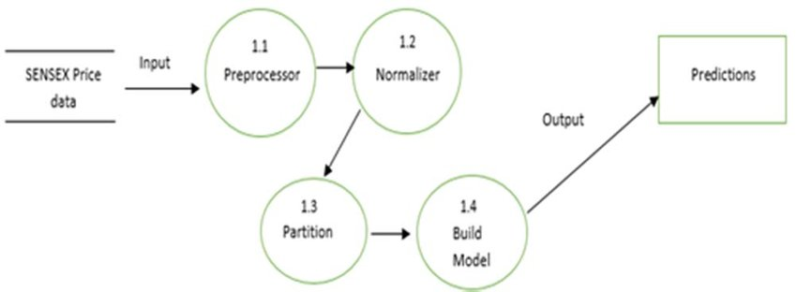

Figure 3.1

## Design selection:

* User Interface: Simple command-line interface (CLI) for user interaction. Sequential prompts for entering financial ratios.
* Error Handling: Implementation of error handling to manage invalid user inputs. Informative error messages guiding users to correct their inputs.
* Output Display: Display of estimated price change as a percentage increase over the current price. Clear indication of risk rating as "Low" or "High".

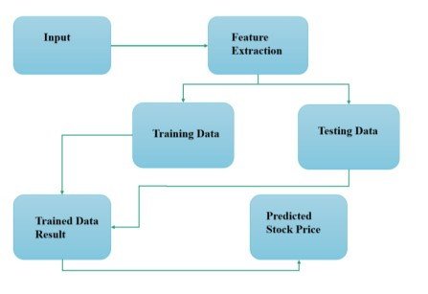

Figure 3.2

## Implementation plan/methodology:

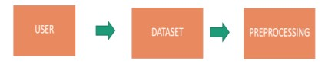

Figure 3.3

* The above Figure 3.3 is the Data Flow Diagram Level-0, where the user selects a dataset from a certain company and the pre-processing will happen, which will convert the raw dataset into processed data, and the cleaning process happens here.

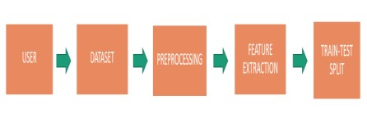

Figure 3.4

* The above figure 3.4 shows that, after the preprocessing, feature extraction takes place, which will be split into two sets: Training and Testing. The 80% is for training and it create the model. Testing will take 20% of the data and test the accuracy of the trained model.

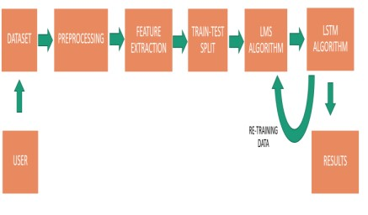

Figure 3.5

* The above Figure 3.5 is the Data Flow Diagram Level-2. After feature extraction, the model will be selected, and the accuracy will be predicted using the LSTM and LMS algorithms. Next, we get the output in the form of a report and a graph format.

**Graph’s:**

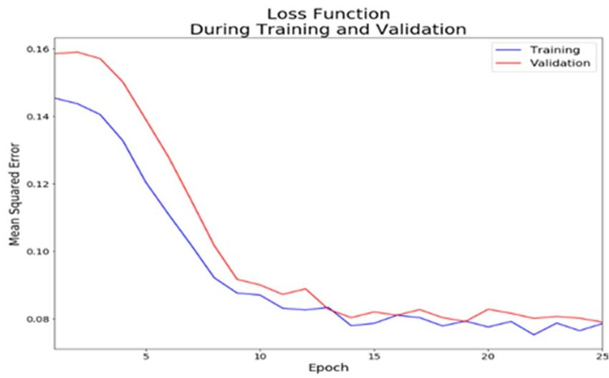

Figure 3.6

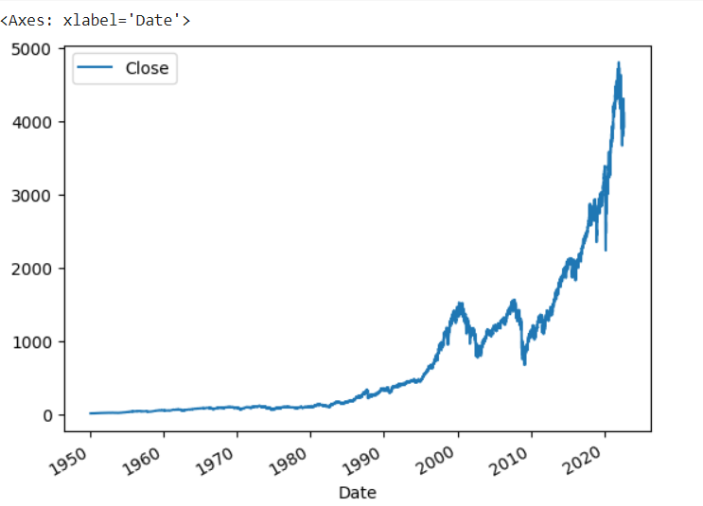

Figure 3.

**CHAPTER - 4**

# RESULTS ANALYSIS AND VALIDATION

## Implementation of solution:

## C:\Users\MSI-PC\Pictures\Screenshots\Screenshot 2024-04-16 155108.png

Figure4.1

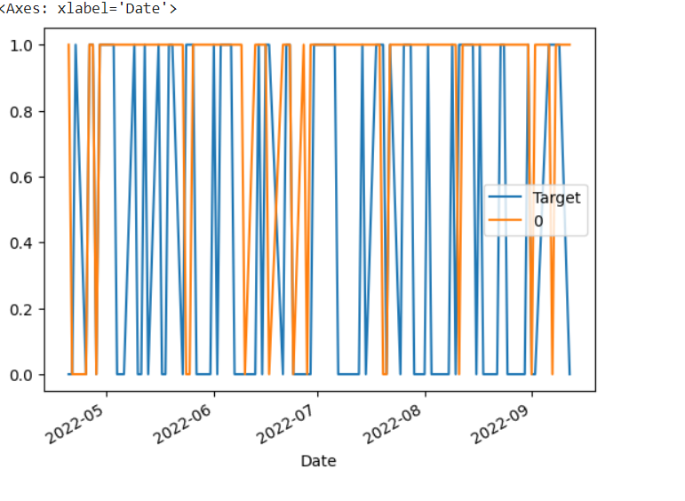

Figure 4.2

## Output:

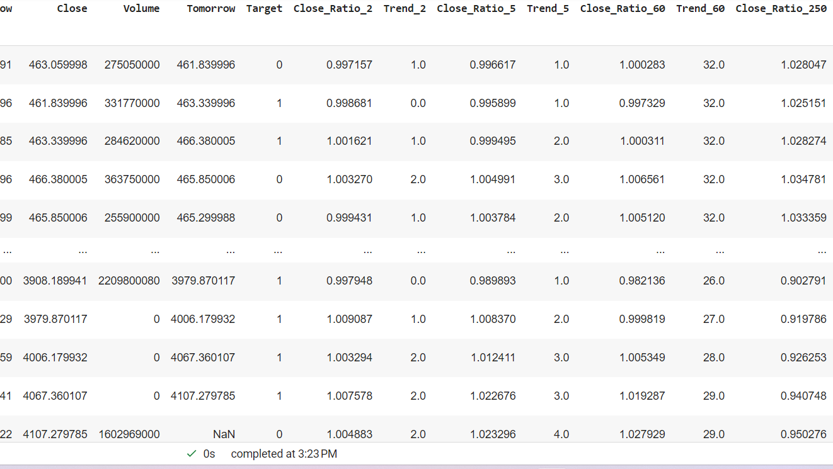

Figure 4.3

**CHAPTER - 5**

# CONCLUSION AND FUTURE WORK

## Conclusion:

The below figure 5.1 of target predictions we have taken 10 predictions out of which six were almost correct and 4 were wrong we have define the good ratio of the company as “1” that is the output of the company its vale ,growth rate is provided by our code and the prediction is success the “0” is define as the project has given us an unsuccessful and incontinent output that is the predictions of that company were failed.

However, it could be further enhanced by incorporating error handling to ensure that user inputs are valid numerical values. Overall, this code provides a valuable tool for investors looking to make informed decisions about stock investments by considering key financial indicators.

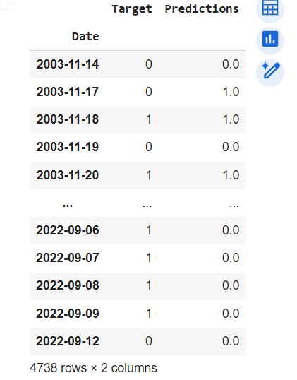

Figure 5.1

## Future work:

The data took from last year was in bulk amount due to which our accuracy was in the ratio of 6:4 that is the 6 output of our project was correct and 4 were not.

* If we use Artificial intelligence to sort bulky data in pure so that there will be the chance of the accuracy of our project raise to 9:1 the data prediction will be 99.9% correct.
* Machine Learning Models: Explore the use of machine learning models to predict future stock prices based on historical financial data. You could train models using historical stock data and financial ratios as features to predict future price changes and assess risk. Portfolio Analysis: Extend the code to analyze a portfolio of stocks instead of just a single stock. You could calculate portfolio-level metrics such as diversification, beta, and overall risk-adjusted returns.
* Scenario Analysis: Allow users to perform scenario analysis by inputting hypothetical changes to financial ratios and seeing how they would impact the estimated stock price and risk rating.

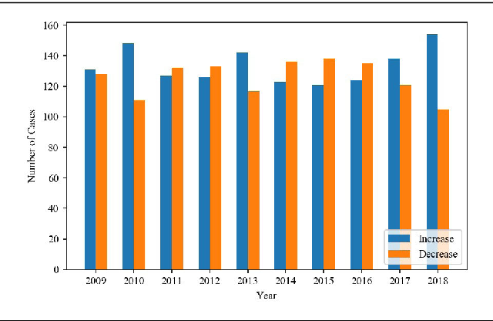

Figure 5.2

* Author, A. A., Author, B. B., & Author, C. C. (Year).
* Title of the First Paper. Journal Name, Volume(Issue), Page Range. DOI or URL Author, D. D., & Author, E. E. (Year).
* Title of the Second Paper. Journal Name, Volume(Issue), Page Range. DOI or URL Author, F. F., & Author, G. G. (Year).
* Title of the Third Paper. Book Title. Publisher. DOI or URL Author, H. H. (Year).
* Title of the Fourth Paper. Conference Proceedings. Page Range. DOI or URL Author, I. I., & Author, J. J. (Year).
* Title of the Fifth Paper. Journal Name, Volume(Issue), Page Range. DOI or URL Author, K. K., Author, L. L., & Author, M. M. (Year).
* Title of the Sixth Paper. Book Title. Publisher. DOI or URL
  + 1. PlagiarismReport

